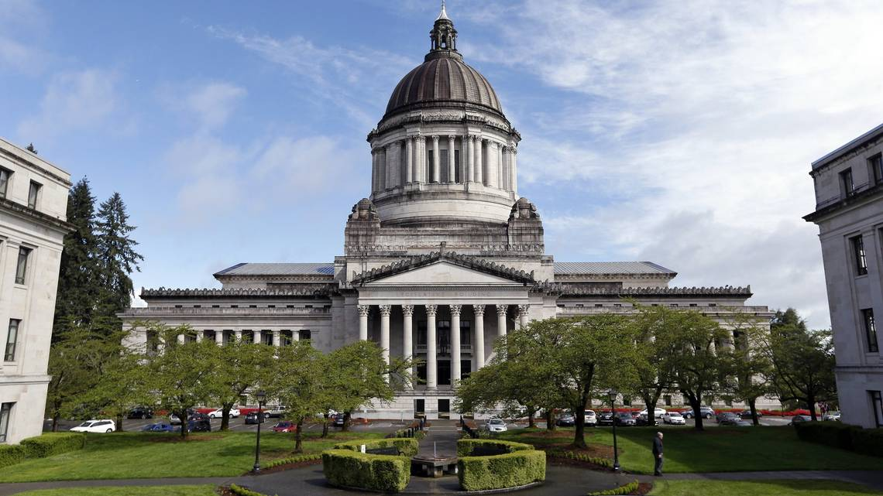
Washington State Labor Council, AFL-CIO
2020 Candidate Questionnaire
Thank you for taking the time to fill out our questionnaire. We are aware that it is lengthy, however, the Washington State Labor Council is the voice of Washington’s working families. The WSLC represents over 550,000 workers, who are represented by over 600 local unions and councils from 55 national and international unions, from every corner of Washington’s economy. Please answer all questions, sign on the last page, and consider signing the supplemental Statement of Principles. You are welcome to email, or mail your completed questionnaire, but please make sure it is signed even if it is returned by email. You may add as much additional space as you need to answer the questions.

Upon completion and receipt of your completed and signed questionnaire you will be contacted with next steps and information to set up a candidate interview with a local Central Labor Council.

Questionnaires should be returned to the attention of Cherika Carter, Washington State Labor Council, AFL-CIO Political and Strategic Campaigns Director, at endorsements@wslc.org or 321 16th Ave South, Seattle WA 98144. You may also contact the Washington State Labor Council, AFL-CIO at 206-281-8901.
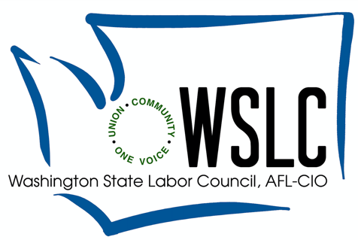

First Name | Middle Name | Last Name
District | Party
Incumbent Challenger Open

Do you currently hold, or have you previously held public office(s)? Describe:

Have you received a Washington State Labor Council, AFL-CIO endorsement in the past? If so, for which office(s)?

Official Campaign Committee Name:

Campaign Address:

City | State | Zip
Campaign Manager | Email | Cell Phone
Social Media Handles:

Are you a Veteran?

Are you now or have you ever been a union member?
Please list union(s) and local(s):

Climate Change: The two greatest challenges we face as humans and as workers on this planet are global climate change, and income inequality. As the average global temperature increases, those of us with the least means will surely carry the greatest burden. Policies to address climate change have the potential to displace workers in the fossil fuel and coal industries, as well as those workers who support those industries in other sectors like construction. At this critical point in time, workers, communities of color, climate activists, and forward-looking governments around the world have an opportunity to grow jobs, protect the most vulnerable, and address climate change.
As an elected official will you commit yourself to supporting policies to reduce carbon emissions by investing in low-carbon jobs in much-needed green energy, water and transportation infrastructure? How would you ensure that these policies will not disproportionately effect communities that depend upon work in carbon-intensive industries? Would you support a transition program to maintain wages, retirement, and healthcare, and help displaced workers find work in environmentally friendly industries? How? Additionally, what policies might you support or propose that would update Washington’s greenhouse gas limits to achieve 95% reduction of emissions by 2050 and net-zero at the same time?

Economic Climate: Washington is considered a high-skill, high-wage state and has one of the highest standards of living in the country. In 2019 Forbes ranked Washington as the 8th best state in the country in which to do business, and in 2017 CNBC ranked Washington #1, with much of this business coming from the Puget Sound area. But at the same time, many business associations decry our state as bad for business claiming wages are too high and workers’ compensation and unemployment insurance benefits are too generous.

How do you view Washington’s economic climate? How would you make our economy stronger in office? How would you propose to bolster Washington’s economy outside of the Puget Sound/Seattle area?

Healthcare: The ACA has made great strides to cover the uninsured. However, thousands remain uninsured, hundreds of thousands still forego necessary healthcare due to out of pocket costs, and the system is not built to put patient care and purchaser savings over profits. As a labor movement we represent frontline care providers and the working people that make healthcare work— even they often do not have affordable and accessible healthcare. The most powerful actors stand in the way of efforts to reduce costs for individuals any time it will cause them lower profits or wealth. And corporate culture takeover of care delivery means that workers are asked to make do with less resources to keep patient safety paramount.

When it comes to healthcare affordability, access, and quality, will you stand with workers, consumers, and purchasers over the hospitals, insurers, pharmaceutical companies and middlemen in reducing costs? Will you support mandatory staffing standards and oversight that ensures patient care is accountable and safe?

Protecting Immigrant Workers and Communities: The Washington State Labor Council, AFL-CIO supports working people with temporary protections granted by the executive branch through the Deferred Action for Childhood Arrivals and Temporary Protected Status programs. By extending relief and work authorization to more than a million people, DACA and TPS have helped prevent unscrupulous employers from using unprotected workers to drive down wages and conditions for all workers in our country. Rather than terminating these successful programs, we need to extend protections that allow people to live and work without fear and afford them the status to assert their rights on the job.

What role should the Washington State legislature play in helping ensure safer workplaces, building a stronger economic future, and supporting the basic rights and dignity of all working people? Would you support legislation to draw clear lines of separation between immigration enforcement and local and state law enforcement? Would you support policies that raise standards and increase protections for temporary guest workers and undocumented students?

Public Health: For years, our state and local public health systems have been chronically underfunded. Twenty years ago, the move to enact $30 car tabs stripped public health of a major, sustainable revenue source – and that funding has never been adequately backfilled by the state legislature. The COVID-19 outbreak has shown clearly that we cannot staff up our public health system while responding to a crisis – as all resources are shifting to fight the COVID-19 outbreak, other disease outbreaks will increase because public health scarcely has enough resources and staff to prevent and respond to usual disease outbreaks (such as tuberculosis and STIs). Following years of study and actuarial analysis, we understand that our state and local public health systems need an additional $450 million per biennium to fully fund Foundational Public Health Services (including communicable disease prevention and response).

Will you support additional funding for Foundational Public Health Services? Why or why not? What ideas do you have for a stable, sustainable funding source for state and local public health?

Quality Education: With the challenges facing society today, and in order to best support our future workforce, it is important that public schools remain strong, have the ability to attract and retain quality, caring educators at all levels, and have resources to meet the needs of all students. Additionally, more students are coming to school with severe issues caused by trauma and/or other mental health needs. Creating a safe learning environment is a critical part of helping all students achieve their full potential.

Do you support fully funding K-12 basic education including professional, competitive compensation and benefits for educators, as well as additional mental health staff (school counselors, nurses, psychologists, social workers, etc) necessary to meet the needs of our students?

Racial Justice: Racism is a system of oppression, designed to divide the working class so the wealthy elite can consolidate their wealth and power at the very top. At the WSLC we believe this to be true, and since 2015 have passed 3 resolutions affirming this, and have committed ourselves to doing the work to become anti-racist organizations. We are moving an anti-racist agenda in our unions because we know the struggle against racial injustice is and must be a working-class struggle in which the entire working class participates. In Seattle for instance the median household income for white families is $105,000, and for people of color significantly less, with the median income of black families being the least at $42,500. And while these are the statistics for Seattle, this trend holds true for the rest of Washington with people of color averaging significantly lower median household incomes.
As an elected official how will you commit yourself to supporting policies to make sure that the economy works for people of all color and backgrounds? How will you address the economic disparities that permeate our state and what policies would you propose to lift up economic opportunities for families of color? Are you committed to working with and supporting communities and organizations who are leading anti-racist agenda’s?

Retirement Security: For several decades, Americans’ ability to retire with dignity has been eroding. As employers have taken defined-benefit pensions away, and high-fee 401(k) plans have become increasingly common, workers have found themselves without the means to retire decently.
As an elected official, how would you address the retirement crisis? Would you commit to opposing efforts to cap existing pensions and replacing them with savings plans that guarantee no benefit at retirement? What policies would you propose to ensure that our elderly can live with security after retirement?

Union Representation: Recent U.S. Supreme Court rulings have undermined workers’ abilities to negotiate with their employers. By imposing “Right-to-Work” policies from the bench, the Courts have forced unions to provide services for free to all workers, regardless of whether or not they pay union fees. This undermines unions’ ability to raise funds, and effectively weakens their negotiating power.
How would you respond to “Right to Work” attacks in Washington State and demonstrate your support for workers to join together to strengthen their voices at work? Would you support innovative reforms to state level employment law to create new avenues for workers to organize? If so what kind of reforms would you propose implementing to protect unions? Do you commit to supporting public employee’s contract fights?

Yes/No Section: In this section, please respond with either “Yes” or “No” regarding your stance on these important policy issues.

Apprenticeships: Washington State has more than 300 occupations with apprenticeship standards in fields ranging from construction to health care to aerospace manufacturing to the culinary arts. Apprenticeships are 2-5-year programs – commonly funded by employers and employees, not the state – that combine on-the-job training with classroom hours. New workers (“apprentices”) work under the supervision of experienced (“journey level”) workers.
Would you promote union apprenticeship opportunities? Yes or No

Contracting of Public Services: Some argue that state government should be reduced in size. They support privatizing certain state functions such as the state printing office, state prisons, centers for the developmentally disabled, and more. In general, unions have opposed these efforts because they replace family wage public service jobs with low-paid private sector jobs, that don’t necessarily save the state money due to contractors’ profits, and often lower the quality of service.
Would you oppose the privatization of public services? Yes or No
Would you support government workers and work to protect their jobs?Yes or No

Competitive Wages in Public Service: The Office of Financial Management - State Human Resources (State HR) is required by law (RCW 41.06.160) to conduct a salary survey to determine the prevailing pay rates for jobs that are comparable to state classified general. According a Survey conducted by the Office of Financial Management, 99% of surveyed state salary positions are below the market value, with 66% being more than 25% below.
As an elected official, will you work to ensure state employees are paid a prevailing wage reflecting fair market value for their services? Yes or No

Gig/Task Based Economy: The National Labor Relations Act excludes workers classified as “Independent Contractors” from organizing under the NLRA. Increasingly though, more and more employers, especially in the emerging task-based economy are misclassifying workers as independent contractors. This misclassification exploits workers, weakens Unions, severely hinders worker’s rights, and limits workers access to Union representation.
Would you support legal and political efforts by these workers to form and join a labor organization? Yes or No

Health Systems Transparency: As our state continues to promote access to affordable quality health care, often times working families lack the information needed to obtain quality, affordable care. Healthcare costs are growing faster than workers can sustain, while policymakers and patients face a delivery system that is increasingly complex and has fewer choices. While we have made some progress toward transparency in costs drivers, our state has not yet achieved the clarity necessary in order to make this information more actionable. The actions of actors in our healthcare delivery systems continue to operate behind a curtain that increases profits at the expense of good health outcomes.
Do you support increasing transparency in our healthcare delivery system to provide more oversight and accountability, creating a sustainable healthcare system that works for us all? Yes or No

Rest breaks: Under state rule, an employee may not be required to work more than three hours without a paid rest break. The current rules stipulate that workers should receive at least a ten-minute, uninterrupted rest break unless the nature of the work permits the use of intermittent breaks that add up to ten minutes. Widespread evidence across industries reveals that workers are not getting ten minutes of uninterrupted breaks and that the intermittent break rule has resulted in workers simply not getting breaks at work.
Would you propose policies to ensure workers are not being exploited and are getting their mandated 10-minute break every three hours? Yes or No

Revenue: Washington has faced a structural budget deficit for more than a decade. Our system of taxes and tax exemptions doesn’t raise sufficient revenue to cover the social, educational, health, public safety and infrastructure needs of our growing population. In addition, our tax structure is considered to be the most regressive in the nation. Yet, the most common tax policies passed by the Legislature have been to create special breaks for big businesses.
Would you support tax incentives that are tied to job maintenance and investments in our workforce here in Washington? Yes or No
Would you support a more progressive tax structure? Yes or No

Strengthening Workplace Standards in Growing Industries: As the cannabis industry grows in our state, workers in this industry need protections. They need the same wage and hour, equal pay, health and safety, and anti-discrimination laws that are afforded to workers in other industries, to apply to theirs as well. Without these protections’ workers are susceptible to increased risks of being injured on the job, wage theft, and unfair work conditions.
Do you support policy that would establish licensing guidelines that promote and uphold living wages, strengthened and enforceable health and safety plans, healthcare coverage, retirement benefits, and other strong standards in the cannabis industry? Yes or No
Do you support the right of cannabis workers to join together to negotiate a fair return on their work? Yes or No

Tax Break Accountability: For decades the Legislature has implemented a series of special tax breaks for employers in certain industries without requiring accountability measures to ensure that they create good jobs. Companies who have taken advantage of this special treatment in the past have not always delivered on their promises to support employment and workforce development in our state.
Do you support tax policies that require companies to create and maintain good, family sustaining jobs here in Washington State? Yes or No
Do you support the use of tax policy to promote job training and apprenticeship opportunities in construction and manufacturing? Yes or No

Wage Theft: It is illegal to not pay or to underpay workers, but many times workers are forced to work off the clock and are not paid their owed wages. The state is also shortchanged in unpaid taxes, unemployment insurance, workers’ compensation premiums, and general revenue. There is currently no administrative remedy to protect workers who were retaliated against for speaking up about wage theft.
As an elected official, would you commit to addressing wage theft and enforcing wages, leave laws, and anti-discrimination laws? Yes or No
Have you ever experienced wage theft? Yes or No

Worker Protections: We have many great workplace protections in Washington — wage and hour, equal pay, health and safety, and anti-discrimination laws. But wage theft, work hazards, and discrimination are problems all too common across industries, and enforcement agencies often have years-long backlogs resulting in less protections for workers.
Do you support creating pathways for workers to achieve and maintain fairness in the workplace, and generating the resources for stronger state enforcement? Yes or No

Workers Compensation: Washington State has a worker’ compensation system that has guaranteed injured workers sure and certain relief, in exchange for giving up the right to sue their employers when they are hurt on the job. Some employers have chosen to self-insure their workers’ compensation coverage – opting out of the state system – and others have formed special rating groups to reduce their rates. Unfortunately, many of these employers aggressively manage claims in an effort to suppress them to reduce costs at the expense of injured workers’ well-being. Either through endless protests and appeals, or through intrusive, frequent medical examinations, some employers have sought to deny relief to workers who are just trying to heal.
Would you support reforming the use of independent medical examinations in workers’ compensation, and help advance policies that level the playing field for injured workers? Yes or No

Please explain why the Washington State Labor Council and its members should endorse you.

Candidate Signature

_____________________________________________________________________________

Date Signed

_____________________________________________________________________________

STATEMENT OF PRINCIPLES FOR PUBLIC OFFICIALS
The Chance to Make Life Better, The Freedom to Join a Union

As a candidate for public office, I am committed to making our community a better place to live and work. I support efforts to raise living standards and to promote good schools, safe streets, a trained workforce and a vibrant local economy. I know that the quality of life in our community depends on the quality of our jobs, and I recognize that unions give employees a voice at work, improve productivity and contribute to the economic vitality of our community.

I respect the right of every working person to pursue equality, opportunity and a better life for themselves and their families. I understand that the decision to join together in a union belongs exclusively to employees, not their employers. I believe that any employer that uses legal or unlawful tactics designed to harass, threaten or fire workers for trying to form a union, does its employees and our community a great disservice. I fully support the principle, guaranteed under federal law, that employees are entitled to a free choice to form a union without interference, intimidation or fear of reprisals.

I am committed to stand by working families that are trying to make life better by forming unions. I will urge employers to remain neutral, respect the choices of their employees and voluntarily recognize a union when a majority of workers has indicated the desire to join one. I will stand with striking workers who want a fair return on their work. I will monitor what goes on in workplaces in our community and speak out when employers abuse their power.

Additionally, I am committed to supporting union workers during my campaign and will use a union printer and sign shop for printing needs, and work with union stage employees for campaign events

On behalf of all working families in our community, I will raise my voice to help restore the chance to make life better and the freedom to join a union.

This is my commitment

Name (print): ___________________________________________________________

Signed:________________________________________________________________

Office Held/Sought: ______________________________________________________

Date: _________________________________________________________________

