Washington State Labor Council, AFL-CIO
2022 Judicial Candidate Questionnaire

Thank you for taking the time to fill out our questionnaire. The Washington State Labor Council, AFL-CIO (WSLC) represents over half a million workers, represented by over 600 local unions and councils of 57 national and international unions from every corner of Washington’s economy.
Please answer all questions, and sign on the last page. You are welcome to email or mail your completed questionnaire, but please make sure it is signed. You may add as much additional space as you need to answer the questions.

Upon receipt of your completed and signed questionnaire, you will be contacted with next steps and information to set up a candidate interview with a local Central Labor Council.
Questionnaires should be returned to the attention of Cherika Carter, Washington State Labor Council, AFL-CIO Political and Strategic Campaigns Director, at endorsements@wslc.org or 321 16th Ave South, Seattle, WA 98144. You may also contact Cherika at 206-384-1133 or ccarter@wslc.org with questions.
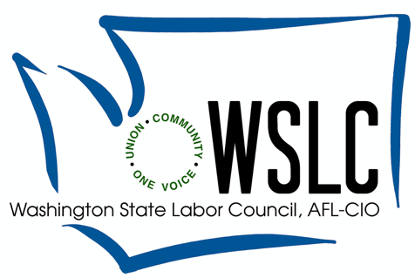

First Name: ___________________________________________________________

Middle Name: _________________________________________________________

Last Name:____________________________________________________________

Judicial Seat Seeking:___________________________________________________

Incumbent____ Challenger ____ Open _____

Do you currently hold, or have you previously held public office(s)? Describe: __________________________________________________________________________________________________________________________________________________________________________________________________________________

Have you received a Washington State Labor Council, AFL-CIO endorsement in the past? If so, for which office(s)? _______________________________________
__________________________________________________________________________________________________________________________________________________________________________________________________________________

Official Campaign Committee Name: ______________________________________

Campaign Address: ____________________________________________________

City:_________________________State:______________Zip Code:____________

Campaign Consultant:______________Email:______________Phone:___________

Campaign Manager: _______________Email:______________Phone:___________

Social Media Handles:___________________________________________________

Are you a Veteran?_____________________________________________________

Are you now or have you ever been a union member?________________________
Please list union(s) and local(s):

- Have you represented a labor union or employer at any time? If so, which union or employer did you represent?

- What is, or was, your specialty in practicing law?

- What do you perceive as being the greatest obstacle to the achievement of justice, if any?

- The past series of judicial appointments and elections have placed the term “judicial activism” in our common vocabulary. What do you think defines “judicial activism?” Under what circumstances is judicial activism appropriate or even recommended?

- How could the costs of seeking justice before a court be reduced? Please give examples of how you have facilitated access to justice for litigants in your law practice or courts.

- Mass incarceration has affected individuals and families across the nation but has had a disproportionate impact on communities of color and people in poverty.

6a) What role do you see yourself having to address this epidemic?

6b) What should the role of prisons be in rehabilitating prisoners? Should prisoners be working in commercial enterprises? If so, under what circumstances and with what worker protections in place?

Candidate Signature

_____________________________________________________________________________

Date Signed

_____________________________________________________________________________

opeiu8/afl-cio

