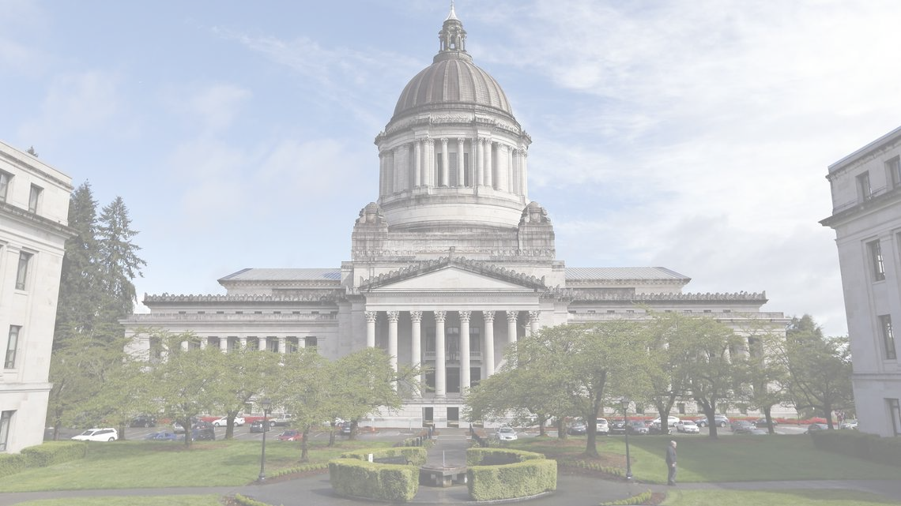
Washington State Labor Council, AFL-CIO 2022
Secretary of State Candidate Questionnaire

Thank you for taking the time to fill out our questionnaire. The Washington State Labor Council, AFL-CIO (WSLC) represents over half a million workers, represented by over 600 local unions and councils of 57 national and international unions from every corner of Washington’s economy.

Please answer all questions, and sign on the last page. You are welcome to email or mail your completed questionnaire, but please make sure it is signed. You may add as much additional space as you need to answer the questions.

Upon receipt of your completed and signed questionnaire, you will be contacted with next steps and information to set up a candidate interview with a local Central Labor Council.
Questionnaires should be returned to the attention of Cherika Carter, Washington State Labor Council, AFL-CIO Political and Strategic Campaigns Director, at endorsements@wslc.org or 321 16th Ave South, Seattle, WA 98144. You may also contact Cherika at 206-384-1133 or ccarter@wslc.org with questions.
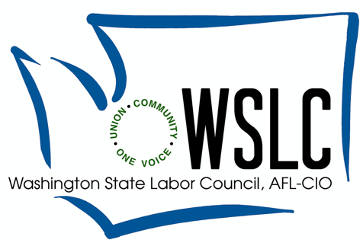

First Name: ___________________________________________________________

Middle Name: _________________________________________________________

Last Name:____________________________________________________________

Seat Seeking:___________________________________________________

Incumbent____ Challenger ____ Open _____

Do you currently hold, or have you previously held public office(s)? Describe: __________________________________________________________________________________________________________________________________________________________________________________________________________________

Have you received a Washington State Labor Council, AFL-CIO endorsement in the past? If so, for which office(s)? _______________________________________
__________________________________________________________________________________________________________________________________________________________________________________________________________________

Official Campaign Committee Name: ______________________________________

Campaign Address: ____________________________________________________

City:_________________________State:______________Zip Code:____________

Campaign Consultant:______________Email:______________Phone:___________

Campaign Manager: _______________Email:______________Phone:___________

Social Media Handles:___________________________________________________

Are You a Veteran?_____________________________________________________

Are you now or have you ever been a union member?________________________
Please list union(s) and local(s:

- What do you think is the primary function of the Secretary of State’s office?

- What do you think is the Secretary of State’s role regarding initiative filing?

- What is the role of the Secretary of State in educating individuals with justice system involvement about their rights to vote in Washington?

- What is the role of the Secretary of State in assisting new citizens to register to vote, and increasing access to voter information?

- Washington has automatic voter registration, but many eligible Washingtonians are not registered to vote. What creative solutions do you have to increase voter registration?

- What creative ideas do you have for increasing voter participation in Washington?

- How will you partner with County Election Officials to strengthen voter education and increase voter participation?

- Should ballot drop boxes be placed in more locations? If so, how would you determine where to place these boxes?

Candidate Signature

______________________________________________________________________

Date Signed

_____________________________________________________________________________

opeiu8/afl-cio

